Web-based Online Job Portal
Software Requirements Specification

Version 1.0



Student Name : Saba Shaheen , Nadia Tabbasum

Group ID : S2202882EC ( MC210202005 , MC210201919)

Supervisor Name : Haseeb Akmal

Revision History
Date (dd/mm/yyyy) | Version | Description | Author
01/07/2022 | 1.0 | This is a web based online job portal it will enable job seekers to post their resumes and facilitate them in finding suitable and attractive jobs as well as companies to post their jobs and search suitable candidates.  In this document I explain following topics,  1)Scope of the project  2) Functional and non-functional requirements  3) Use-Case Diagram  4) Usage Scenarios  5)Adopted Methodology  6)Work plan in Gantt chart. | S2202882EC-  (mc210202005, mc210201919)

Table of Contents | Pg. #
- Scope (of the project) | 04
- Functional Requirements AND Non Functional requirements | 05-07
- Use Case Diagram | 07
- Usage Scenarios | 08-17
- Adopted Methodology | 17-25
- Work Plan (Use MS Project to create Schedule/Work Plan) | 26

SRS Document

- Scope of Project:

This online job portal will facilitate users to create an interactive job vacancy portal for candidates. This web application will help updates both job seekers as well as the companies to apply for jobs and to recruit them. The objective of the app is to enable jobseekers to create their online resumes and find appropriate jobs while companies to publish their vacancies and find suitable candidates. It enables jobseekers to post their resume, search for jobs, view personal job listings. It will provide various companies to place their vacancy profile on the website and also have an option to search candidate resumes. Apart from job-seekers and Companies (Job Provider) there will be an admin module to manage complete Portal as well as jobseeker and companies.

- Functional Requirements:

- The system shall be able to register users as candidates or job-seekers along with their personal profile maintenance including name, contact information, address, location, profile pic, email addresses etc.
- The system shall be able to allow candidates to maintain their professional profile that includes professional summary, skills, personal qualification, experiences, certifications, publications, patents, honours and awards, languages interests, hobbies, causes, followings etc.
- The system shall be able to allow candidates to upload their C.V in .PDF format.
- The system shall be able to register companies as users and add their portfolio including introduction, web address, email address, postal address, employees, posts, events, followers, offices etc.
- The system shall allow companies to post vacancies / jobs so that candidates can search. These job posting should contain job description with salary, required qualification and skills, job placements or locations and relevant necessary information like posting date, expiry date etc.
- The system shall be able to export candidate C.V based upon all the information that candidate and entered online.
- The system shall be able to download candidate C.V that he/she has already uploaded in .PDF format.
- The system shall support audio / video content, where necessary.
- The system shall support real-time communication among users (candidates and company representative) via online chat, audio and video call.

- Non-Functional Requirements:

User Interface:

Website must be designed with a user friendly interface strongly compliant to standard
GUI pertaining to font size, color of text, fields’ alignment and positioning on the form
etc. The idea is to come up with a simple but comprehensive Website without
unnecessarily complicating it.

Hardware Requirements:

Operating System: Window 10
Processor: Core i5 or better
Memory: 4GB RAM or better
Disk: 200 GB HDD or Better

Performance:

System performance should be very good. All candidates , admin and company users should be
Satisfied. The website load time should be less. System should produce results quickly

Efficient:

This should be efficient and works properly and efficiently.

Maintainability:

Website should be maintained and well organized. In case of any problem job portal can be under maintenance for approximately three hours.

Usability:

The website’s interface has to be user-friendly and easy to use

Reliability:

System and website behavior should be correct. The website should be able to complete its on-going operations in spite of any error or problem within defined response
time.

Supportability:

It will be all browser supported like google chrome, opera etc.

Availability:

System should be available 24/7. Employers can post jobs on the website throughout the week at any time during the day. In the case of unplanned system downtime, all features will be available again after one working day.
Robustness:

System should be able to behave normally, roll back or commit
processing/ transaction in case of system failure or crash.

Safe operation:

System should ensure the safe operation of the machinery.

Security:

Only the users with the role “site admin” can view the applicant’s verified phone number.

Recoverability:

If a major incident happens on the website and, the business must take measures to go back to being fully operational within three days.

Reliability:

Applicants can access their resume 98% of the time without failure.

TOOLS:

- Server-side Programming language: PHP
- Framework: we use framework of PHP of your choice
- Scripting and Styling Languages: HTML, CSS
- Client-Side Scripting: JavaScript, JQuery .
- Database: MySQL with preferred IDE as PHP Storm .
- Local Host Server: XAMPP or WAMP
- Unified Modelling Language (UML): Microsoft Visio, IBM Rational Rose

- Use Case Diagram(s):

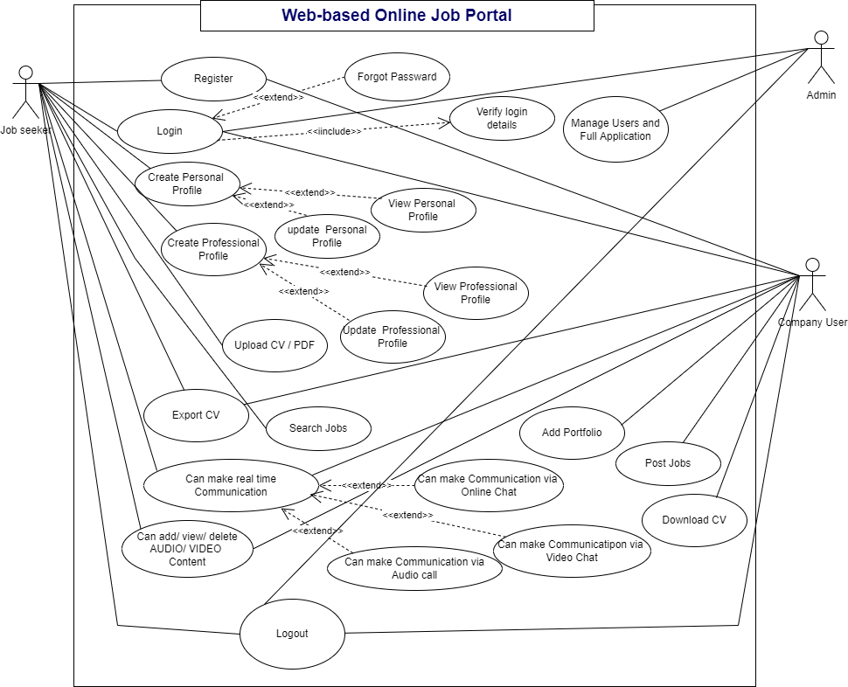

- Usage Scenarios:

Use Case Title | Register
Use Case Id | WJP- REG-01
Requirement Id: | FR-01
Description :

Candidate can register through proper registration form by filling with valid credentials.
Pre Conditions:
The customer runs the application and clicks on registration from the front menu.
Task Sequence:

1. Click on registration from the menu.
2. Fill the form and submit.
Exceptions:

Its occur if some provide invalid data such as wrong email id etc.
Post Conditions:

Customer will able to log in and performed their specified actions and log out.
Alternative path:
No
Authority: Candidate/ job seeker
Modification history: 1.0
Author : Saba Shaheen(MC210202005)
Nadia Tabbasum(MC210201919)

Use Case Title | Login
Use Case Id | WJP-LOG-02
Requirement Id | FR-00
Include use case | Verify login details
Extend use case | Forgot password
Description :

Members can log in through proper user-friendly login interface for performing their actions according to their roles.

Pre Conditions:
Members must have Registered account in the application.
Task Sequence:

i. Run the application.
ii. Click on the login button from the menu.
iii. Give Email and Password.

Login details will be verified.
If user forgot password
- Click on forgot password
- Reset link will be sent via Email .
- User reset password.
Exceptions:

An exception occurs if email or password is wrong.
Post Conditions:

Members can use and perform their desired actions after login to the system.
Alternative path: No
Authority: Admin, Company user, candidate.
Modification history: 1.0
Author: Saba Shaheen(MC210202005)
Nadia Tabbasum(MC210201919)

Use Case Title | Create personal Profile
Use Case Id | WJP-PP-03
Requirement Id: | FR-01
Extend use case | View / update personal profile.
Description:
This use case is about to create an maintain personal profile , candidate can add/view/delete profile including name, contact information, address, location, profile pic, email addresses etc.

Pre Conditions:
User must have an registered account to create personal profile.
Task Sequence:

- Run the application
- Login to the application.
- Tap on create personal profile.
- Fill the given form.

Exceptions:
Exception will be given on adding wrong data
Post Conditions:
Profile is created successfully.
Alternative path: No
Authority: candidate / job seeker
Modification history: 1.0
Author: Saba Shaheen(MC210202005)
Nadia Tabbasum(MC210201919)

Use Case Title | Create professional profile
Use Case Id | WJP-CPP-04
Requirement Id: | FR-02
Extend use case | View / update professional profile.
Description :
This use case is about to create professional profile. Job seeker/Candidate can add/view/delete profile includes professional summary, skills, personal qualification, experiences, certifications, publications, patents, honor’s and awards, languages interests, hobbies, causes, followings etc.

Pre Condition:

Job seeker/Candidate tap on professional profile button and can add/view/delete professional profile.

Task Sequence:
i. Login Required.
ii. Click on the professional profile section of the application.
iii. Add the details in the given form.
Exceptions:
Exception will be given improper and incomplete information or loss of internet connection.
Post Conditions:
Job seeker/Candidate added/viewed/deleted professional profile successfully

Alternative path: No
Authority: candidate / job seeker
Modification history: 1.0
Author: Saba Shaheen(MC210202005)
Nadia Tabbasum(MC210201919)

Use Case Title | Upload CV/ PDF
Use Case Id | WJP-UCV-05
Requirement Id: | FR-03
Description :

This use case is about CV uploaded by the candidate / job seeker.
The CV must be in PDF format

Pre Conditions:
Login required

Task Sequence: you can

- Login to the application .
- Tap on upload CV button.
- Choose the file.
- Click on ok button.
Exceptions:

Exception will be given loss of internet connection on uploading file .
OR uploading file in any other format except PDF.
Post Conditions:
Candidate CV uploaded successfully.

Alternative path : No
Authority: candidate / job seeker
Modification history: 1.0
Author: Saba Shaheen(MC210202005)
Nadia Tabbasum(MC210201919)

Use Case Title | Search job
Use Case Id | WJP-SRJ-06
Requirement Id: | FR-5
Description :

The Job seeker/Candidate can search various job will be shown there. Candidate can choose their relevant job.

Pre Conditions:
User must be log in.
Job seeker/Candidate tap on search button and search job.
Task Sequence:

1. Job seeker/Candidate open the application.
2. Go to Search slot.
3. Tap on search button to search a job.
Exceptions:
Exception will be given loss of internet connection or putting wrong keywords to search.
Post Conditions:
Candidate can search job now.

Alternative path : No
Authority: job seeker/ Candidate
Modification history: 1.0
Author: Saba Shaheen(MC210202005)
Nadia Tabbasum(MC210201919)

Use Case Title | Export CV
Use Case Id | WJP-ECV-07
Requirement Id: | FR-06
Description :
This use case tells that job seeker and company user both can export CV.
It means that the information entered manually will be converted into file format like PDF etc.

Pre Conditions:
User must be login the application.

Task Sequence:
- Login to the application
- Tap on export CV
- The CV will be export.

Exceptions:
Poor internet connection
Post Conditions:
CV exported successfully

Alternative path : No
Authority: Company user, candidate / job seeker.
Modification history: 1.0
Author: Saba Shaheen(MC210202005)
Nadia Tabbasum(MC210201919)

Use Case Title | Add portfolio
Use Case Id | WJP-AP-08
Requirement Id: | FR-04
Description :

Company can add/view/delete portfolio including introduction, web address, email address, postal address, employees, posts, events, followers, offices etc.

Pre Conditions:

Company user tap on portfolio button and can add/view/delete portfolio data.

Task Sequence:
1. Company user open the application.
2. Go to portfolio slot.
3. Tap on add portfolio button.

Exceptions:
Exception will be given loss of internet connection or if there is any duplication of information exist.
Post Conditions:
Successfully task completed.

Alternative path : No
Authority: Company user
Modification history: 1.0
Author: Saba Shaheen(MC210202005)
Nadia Tabbasum(MC210201919)

Use Case Title | Post jobs
Use Case Id | WJP-PJ-09
Requirement Id: | FR-05
Description :
This use case is about to tell that company can post their jobs on job portal.
Company can post vacancy , update post with job description , salary, required qualification and skills, job placements or locations and relevant necessary information like posting date, expiry date etc.

Pre Conditions:
Company user must be login
Company tap on post vacancy button and post vacancy.

Task Sequence:
1. Company open the application.
2. Go to post vacancy slot.
3. Company can post job vacancy by tap on post vacancy button.
Exceptions:
Exception will be given loss of internet connection or if there is any duplication of post is available from same company.
Post Conditions:
Company posted vacancy successfully
Alternative path : No
Authority: Company user
Modification history: 1.0
Author: Saba Shaheen(MC210202005)
Nadia Tabbasum(MC210201919)

Use Case Title | Download CV
Use Case Id | WJP-DCV-10
Requirement Id: | FR-07
Description :
The candidate / job seeker and Company can download CV.

Pre Conditions:
User tap on download C.V button.

Task Sequence:

- Login to the application.
- Tap on download CV button .
Exceptions:
Poor internet connection or corrupted file.
Post Conditions:
CV downloaded successfully.
Alternative path : No
Authority: Candidate/ job seeker , Company User.
Modification history: 1.0
Author: Saba Shaheen(MC210202005)
Nadia Tabbasum(MC210201919)

Use Case Title | Add/view/delete audio/video content
Use Case Id | WJP-AVC-11
Requirement Id: | FR-08
Description :
This use case is about that system support audio/ video content where necessary.
Company and candidate both can add / view / delete audio video content.

Pre Conditions:

User tap on audio /video content and can add/view/delete in it.

Task Sequence:
1. User open the application.
2. Go to Audio/video content slot.
3. User can view/edit audio video content facilitate by system.
Exceptions:

loss of internet connection.
Post Conditions:
Content added successfully.
Alternative path: No
Authority: candidate / job seeker, Company user.
Modification history: 1.0
Author: Saba Shaheen(MC210202005)
Nadia Tabbasum(MC210201919)

Use Case Title | Can make real-time communication
Use Case Id | WJP-MRC-12
Requirement Id: | FR-09
Extend use cases | Can make real-time communication via online chat,  Can make real- time communication via Audio chat,  Can make real- time communication via video chat.
Description :

This use case is about that the system support real-time communication among users (candidates and company representative) via online chat, audio and video call.

Pre Conditions:
User login required.
User tap on communication button and can have real time communication via online chat or audio and video call.

Task Sequence:

1. User open the application.
2. Go to real-time communication slot.
3. User can make online chat or audio and video call facilitate by system.
Exceptions:

Exception will be given loss of internet connection
or
dialing wrong contact data.
Post Conditions:
User have made real time communication successfully
Alternative path : No
Authority: Company user, job seeker.
Modification history: 1.0
Author: Saba Shaheen(MC210202005)
Nadia Tabbasum(MC210201919)

Use Case Title | Manage users and full Application
Use Case Id | WJP-MUA-13
Requirement Id: | FR-10
Description :

Admin can manage complete Portal as well as jobseeker and companies. Admin will be responsible for database and full application maintenance.

Pre Conditions:

Admin must be login to the application.

Task Sequence:

1. Admin open the application.
2. Login into the application.
3. Manage all the activities on the app of company and job seeker/candidate.

Exceptions:
No
Post Conditions:
Admin manage the application .
Changes made by user are updated.

Alternative path :. No
Authority: Admin
Modification history: 1.0
Author: Saba Shaheen(MC210202005)
Nadia Tabbasum(MC210201919)

Use Case Title | Logout
Use Case Id | WJP-LOG-14
Requirement Id: | FR-00
Description :
This use case is about the logout operation.
Admin ,Company and job seeker may logout after login .

Pre Conditions:
User must be login .
User press logout button.

Task Sequence:
1. User pen the application.
2. Go to setting.
3. User tap on logout button and log out the app.
Exceptions:
No
Post Conditions:
Sessions will be destroyed and users redirected to the login page.

Alternative path: No
Authority: Admin, Company user , candidate/ job seeker.
Modification history: 1.0
Author: Saba Shaheen(MC210202005)
Nadia Tabbasum(MC210201919)

Adopted Methodology

Software engineering is the practice of using selected process techniques to improve the quality of a software development effort. This is based on the assumption, subject to endless debate and supported by patient experience, that a methodical approach to software development results in fewer defects and, therefore, ultimately provides shorter delivery times and better value. The documented collection of policies, processes and procedures used by a development team or organization to practice software engineering is called its software development methodology (SDM) or system development life cycle (SDLC).
Software engineering has many number of Software Development Lifecycle Model. Each has its own strengths and weaknesses. Some of them are briefly described below:
- Existing Methodologies:
Following are the methodologies that are used for software development.
- Build-and-fix Model
- Waterfall Model
- The V Model
- Rapid Prototyping Model
- Incremental Model
- Spiral Model
- Waterfall Model:

This is the traditional life cycle model. It assumes that all phases in a software project are carried out sequentially and that each phase is completed before the next is taken up. It was a great step forward in software development as an engineering discipline. The figure also depicts the single-level feedback paths that were not part of the original model but that have been added to all subsequent improvements of the model; they are described here. The original waterfall model had little or no feedback between stages, just as water does not reverse or flow uphill in a cascade but is drawn ever downward by gravity. This method might work satisfactorily if design requirements could be perfectly addressed before flowing down to design creation, and if the design were perfect when program implementation began, and if the code were perfect before testing began, and if testing guaranteed that no bugs remained in the code before the users applied it, and of course if the users never changed their minds about requirements.

Advantages:

- Easy to understand even by non-technical persons i.e., customers.
- Easy to use as software development proceeds.
- Each stage has well defined deliverables or milestones.

Disadvantages:

- The biggest drawback of Waterfall model is that it does not support iteration.
- Another disadvantage of Waterfall model is that it is sequential in nature. One cannot start with a stage till preceding stage is completed e.g., one cannot start with the system design till all the requirements are understood and represented.
- Customer gets opportunity to review the product very late in life cycle because the working version of product is available very late in software development life cycle.
- The Waterfall model also has difficulty in accommodating changes in the product after the development process starts.
- Amount of documentation produced is very high.

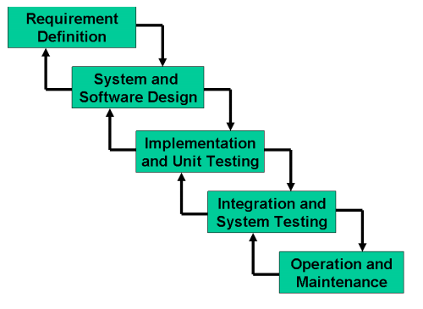

- The Spiral Model:

Another evolutionary life cycle model that combines the linear nature of the Waterfall model and the iterative nature of the Prototyping model is the spiral model. The project life cycle is divided into phases, and each phase is executed in all of the iteration of the Spiral Model.

The radial coordinate in the diagram represents the total costs incurred till date. Each loop of the spiral represents one phase of the development. The model is divided into four quadrants, each with a specific purpose. Each spiral represents the progress made in the project. In the first quadrant, objectives, alternative means to develop product and constraints imposed on the product are identified. The next quadrant (right upper) deals with identification of risks and strategies to resolve the risks. The third bottom right quadrant represents the Waterfall model consisting of activities like design, detailed design, coding and test. With each phase after customer evaluates the product, requirements are further refined and so is the product. It is to be noted that number of loops through the quadrants are not fixed and vary from project to project.

Spiral model is also termed as process model generator or Meta model. For example if any project requirements are not clear models like Prototyping or Incremental can be derived from the spiral model.

Advantages:

- The model tries to resolve all possible risks involved in the project starting with the highest risk.
- End users get a chance to see the product early in life cycle.
- With each phase as product is refined after customer feedback, the model ensures a good quality product.
- The model makes use of techniques like reuse, prototyping and component based design.

Disadvantages:

- The model requires expertise in risk management and excellent management skills.
- The model is not suitable for small projects as cost of risk analysis may exceed the actual cost of the project.
- Different persons involved in the project may find it complex to us

The Spiral Model:

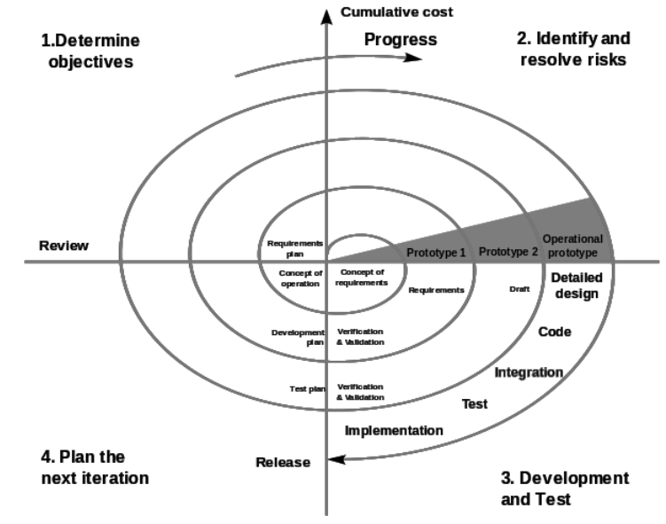

- VU Process Model:
VU Process Model Diagram:

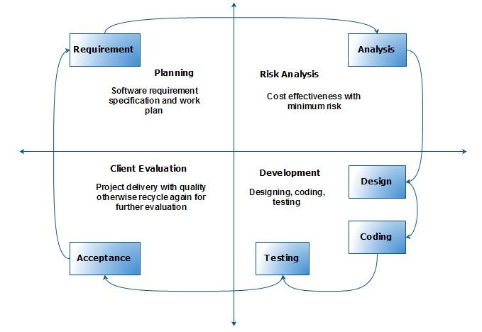

The adopted methodology is “VU Process Model” which is combination of waterfall model and spiral model.

In the VU process model we take advantages of waterfall model and spiral model and then add them to make another powerful efficient model for software development projects. This model also contains sequence of activities or tasks. There should be a risk analysis feature apply to every step in the process to make error free software or application. An efficient and important feature of this model is that this model allows us to complete one phase/step and then re-design the current phase if it want re-designing or debugging but in some models it is not possible to go back for debugging in each step but in this model we easily go back for debugging in each step. This model contains some phases. Such as;

- Requirement Analysis:
In this phase we define functional and non-functional requirements which are the basic requirements of the project. To make the project error free and fulfill user expectations this step is essential. We think about all requirements related to the project that will help in future activities and finally we create a proper requirement analysis report. We say this phase as a road map of our project.
- Risk Analysis and Work Plane:
In this phase we make an estimate of our project with respect to time which means that we develop the project while focusing on our estimated time. Due to this approach developers are able to develop product in time or develop software product without delay. In this phase we also keep in mind that what kinds of risk is involve in our project, we identify all risks to prevent our project from any loss.
- System Design or Designing:
In this phase we define overall system architecture. We define that what we are going to develop what will be its interface and how it behaves.
- Implementation:
In this phase a software product is ready to start develop by developers. In this phase different team members do their work to complete the project such as programmers have a responsibility to do required programming, graphics designers create graphics for product. Internal work is even an important task for designers but end-users firstly see the software interface, it software interface looks pleasant then user will then its internal working. So pleasant, nice and attractive interface designing is also an important activity as programming or internal working activities. In this phase only 20% of the work is based on programming and remaining 70% work is based graphics and editing.
- Verification or Testing:
In this phase developers run the software product and completely test the product until they satisfy. During this phase all features of product is kept in mind and check it by user all features one by one. For example product is a calculator then developers perform all operations such as addition, subtraction, multiplication. If all operations are working correctly then software product is declared PASS and it is now ready for delivery to the client or end-user.

- Reasons for choosing the Methodology:

There are some reasons of choosing “VU Process Model”. Such as;

- We choose VU process model because it is a combination of benefits of two life cycle models which gives us an efficient and powerful model to develop the application.
- We have benefit of waterfall model that we easily cascade or move from one phase to another and if error occurs then we go back to the current phase and start debugging process.
- We have an advantage of spiral model that we do a special activity that is “Risk Analysis” at each phase prevent the project from any loss or damage e.g. software product crash. This type of loss is actually loss of money, time and client trust which is really dangerous for an organization future.
- Each phase is check by developers for any error if error occurs then they resolve it.
- During product development the developers create a progress report at the end of each phase. The progress report quickly tells product is going good or bad.
- Before practically coding developers ensure that all requirements of the project are complete and correct. After that they practically start coding.

VU PROCESS MODEL OF Web-based Online Job Portal:

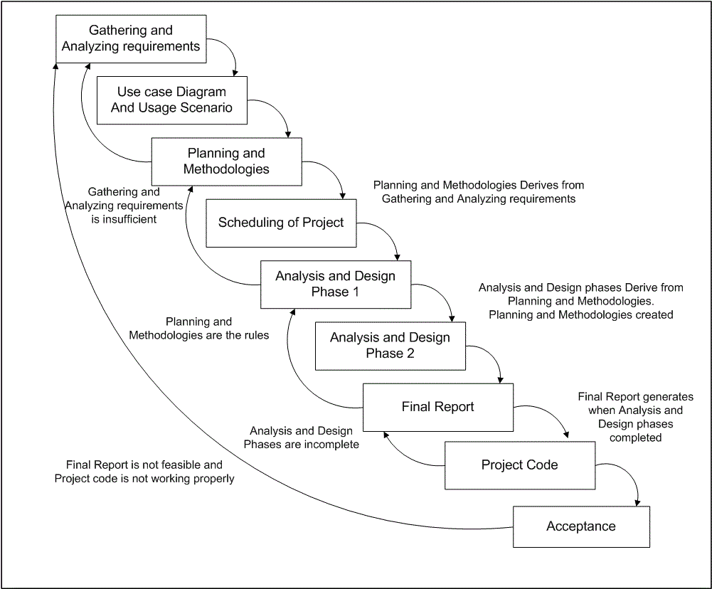

- Work Plan:
Gantt Charts are useful tools for planning and scheduling projects. They allow to assess how long a project should take, determine the resources needed and layout the order in which tasks need to be carried out.
Given below Gantt chart represents the plan by which we plans to complete a quality project within a given amount of time.

